The Design of Emergency Safety Shower Heads to Comply with the Proposed EU Standard

M. Burby ^{1*}, G.G.Nasr², A.J.Yule³, and T. Hughes ⁴

^{1, 2,3} Spray Research Group (SRG)
Institute of Materials Research (IMR)
University of Salford
School of Computing Science and Engineering
Newton building
Manchester M5 4WT

UK
Tel: 01282 697086
Mobile: 07863 165 971

⁴ Hughes Safety Showers Ltd

Managing Director
Stockport SK6 2SS
UK

Abstract

Emergency safety showers are used to decontaminate persons who have come into contact with hazardous substances. It is therefore important that the safety shower produces a sufficient deluge of water with suitable patternation to wash off the contaminant from the person. There is a proposed EU standard for shower heads which dictates a radial and circumferential distribution to which these emergency safety showers have to conform to. From previous research into current shower head designs, in relation to the proposed EU standard, it has been found that a number of these designs do not meet the proposed standard with regard to radial and circumferential distribution of water.

Introduction
Safety showers are used to decontaminate individuals who have come into contact with hazardous substances. Standard practice is to apply water to the individual for 15 minutes [1], [2]. There are currently three major designs of safety shower heads on the market and each produces a spray in a different manner. These designs have been labeled ‘Rose type’, which delivers the water through a number of small orifices, rather like a watering can, ‘Filmer type’, which uses a combination of a filmer surface and a central plate with a number of orifices to distribute the water and a ‘Nozzle type’ shower head which uses a swirler plate and a single outlet orifice to produce a spray.
In this investigation the Filmer type shower head design was modified and patternation tests were carried out to establish the circumferential and radial distribution. From these tests a design methodology was established through which to control the radial and circumferential distribution of the spray and hence achieve the proposed EU standard [3] for emergency safety showers.

EU Standard
The EU standard for overhead emergency shower head designs states that the design should meet the following requirements [4]:
A constant flow of water supplied by the shower head shall be a minimum of 60 l/min at a flow pressure of a minimum of 1bar measured where the shower is connected to the water system. The shower head shall be capable of delivering this supply for a minimum of 15 minutes.
As shown in Fig. 1, at a distance 700 mm below the shower head, 50%, ±10% of the volume of water delivered shall fall in a circle with a radius of 200 mm; the water level in the individual containers in this circle shall not deviate by more than 30% from the mean value.
At this measuring level, the area reached by 95% o (minimum) f the water shall be limited to a circle with a radius of 400mm.

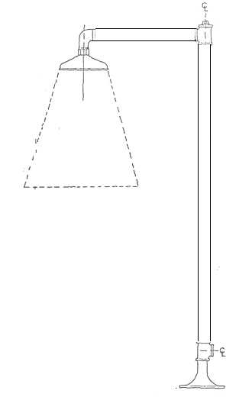
95 % of the water collected should be limited to a radius of 40 cm
700 mm
800 mm

Figure 1: EU plumbed in shower standard.

The water spray pattern shall be such as to ensure that it is possible for a person underneath the shower to breath normally and the velocity of the spray shall be low enough to be non-injurious to the user.

Experimental Apparatus
The test rig was constucted from aluminum box sections which incoporated grooves that allowed the pattternator and shower head support frame to be moved vertically. Perspex sheets were attached to three sides of the test rig to contain the spray, as shown in Fig. 2. Water was supplied fom a header tank, which also incorporated a heater, which allows the temperature of the water supply to the shower head to be adjusted. A pump is used to obtain the desired flow rates of 60 l/min. A rotameter is used to set the flow rate, which is controlled by a valve. Water from the shower head is collected in a sump which discharges to the factory drain.

Patternation Tests
Patternation test were carried out to measure the radial and circumferential distribution of the spray produced by the different shower head designs. The results of these measurements were then compared to the EU standard to see whether the shower head designs meet the required spray distribution.
The patternator as shown in Fig. 3 consists of 17 collection sectors. The centre has a collection diameter of 200 mm and subsequent sectors are in annuli increasing in diameter by 200 mm increments up to the outer diameter of 1000 mm. Water that is collected in these sectors passes through a drain hole into 10 litre measuring receptacles located under the patternator. The height of the patternator in relation to the shower head can be adjusted using the adjustable arms that the patternator is mounted upon, as shown in Fig. 2.

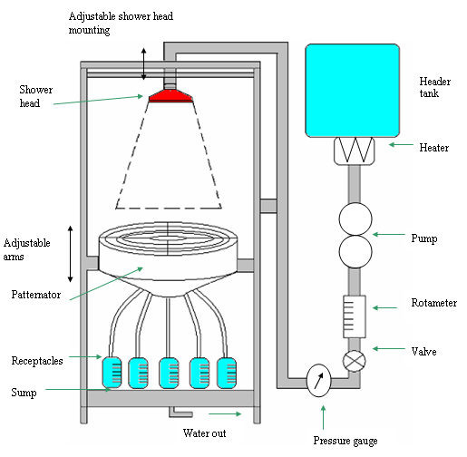

Figure 2: Schematic of the test rig.

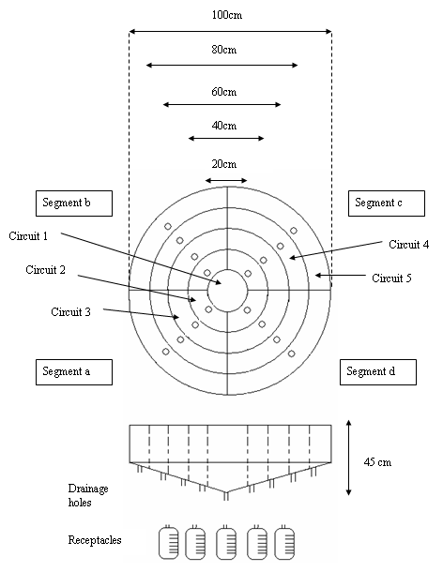

Figure 3: Patternator.

As shown in Fig. 3 circuit 1 was not divided into 4 segments as the collection areas would have been too small. The sector was therefore kept as one with a diameter of 200 mm. This would approximately represent the area of the head of a person being decontaminated. An important criterion for the shower head is to deliver sufficient water into this central area, as it ensures the water will be covering the head.

The circumferential distribution for the water collected within the 200 mm radius was calculated by area weighting the water collected in circuit 1, and for the segments in circuit 2. A mean was calculated from these five values and individual values had to be within 30% of this mean value of water collected within each of these segments.
During the post-processing the total flow rate collected in all the 5 circuits was compared with the total theoretical value of 60 l/min. During testing collected values were within ± 5% of the theoretical value. If this was not achieved the patternation tests were repeated.

Current Filmer Designs
The filming type of shower heads require modifiication to meet EU standardsare. As shown in Fig. 4., Filmer_A and Filmer_B shower heads are very similar in design. The design consists of an inner impact plate which has a number of perforated holes and an outer filming bowl. This arrangement produces two separate sprays. The current designs though similar have different problems associated with their design.
Filmer_A design suffers from very poor circumferential distribution partly due to poor filming on the bowl, as shown in Fig. 4., whilst Filmer_B shower head produces a very good film but lacks suitable radial distribution due to surface tension pulling the film inwards. This results in large amounts of water being collected in the central collection area, as shown in Fig. 6. Both designs suffer from the holes in the impact plate not discharging full and with a number of holes not discharging water at all.

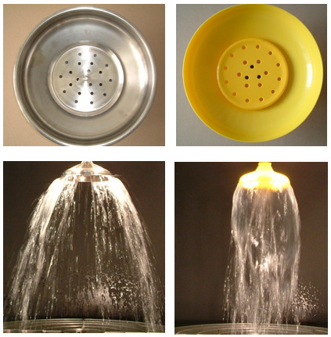

Figure 4: Filmer designs.

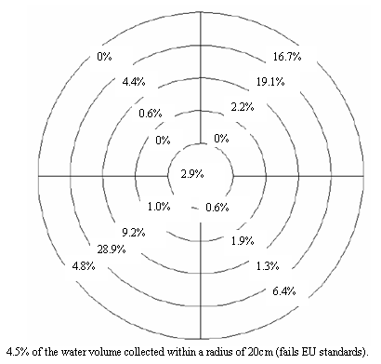

Figure 5: Filmer_A patternation results (% water collected).

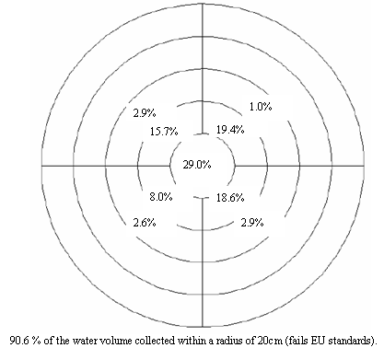

Figure 6: Filmer_B patternation results (% water collected).

Modifying the Filmer Design
As shown in Fig. 7, these shower heads try to combine a central sprinkler (from the impact plate) and an outer spray curtain (from the filmer plate). A design aim should be that the two sprays combine to give even coverage at 700 mm downstream, with 50% within 200 mm radius and the rest within 400 mm radius. To take into account over spray from the inner area a 55/ 45% inner to outer split was chosen as a ‘first guess’.

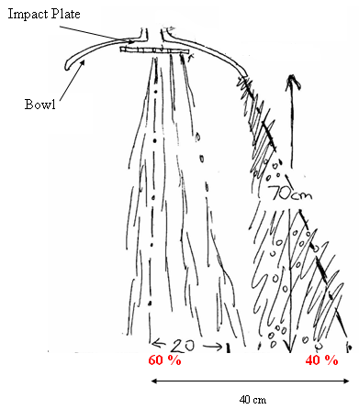
Filmer plate

Figure 7: Desired flow split.

From testing the performance of the shower head is a function of the following parameters, as shown in Fig. 8 and will be discussed in turn:

- Flow split
- Bowl shape
- Impact plate hole arrangement/ filmer gap
Inlet pipe

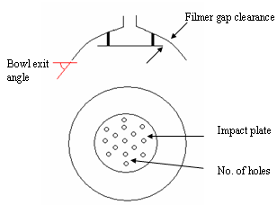

Figure 8: Design features of filmer designs.

Flow Split
As mentioned, an appropriate 55:45% flow split between the inner and outer flows was initially desired, with 55% of the water passing through the impact plate and 45% of the water passing the filmer surface.
To ensure the flow areas are flowing full the total exit area (impact plate holes + filmer gap) has to be less than the inlet area of the pipe. The flow split was calculated for the designs, as shown in Table 1.
It is clear from the calculations that Filmer_A and Filmer_B have too much discharge area when compared to the total pipe inlet area. That is one of the main reasons why a number of the holes in the central impact plate do not flow full, resulting in jets of water being discharged at high ejection angles. This results in the majority of the water discharging from the holes in the impact plate spraying past a radius of 200mm. In the modified design a 42% inner to outer flow split has been achieved along with a significant reduction in the total discharge area in relation to the inlet pipe area.

Inlet Pipe Area (mm²) | 555
 | Filmer_A | Filmer_B | Modified_filmer
Total impact plate hole area (mm²) | 471 | 808 | 342
Total impact plate area (mm²) | 1885 | 3874 | 471
Total discharge area (mm²) | 2356 | 4682 | 813
Inner/outer flow area split (%) | 20 | 17 | 42

Table 1: Hole areas.

Bowl Shape
The exit angle of the bowl is important in achieving the required radial water distribution beyond 200 mm radius (at 700 mm downstream). The initial bowl exit angle θ for both filmer designs was 10 and 15º from the vertical. This would explain the limited radial distribution with the current bowl arrangements. Experimentation into cutting back the filmer bowl (and thus reducing the exit angle) has shown that a suitable radial distribution can be achieved with an exit angle in the region of 45ْْ.
A droplet trajectory model was developed to predict the radial distribution of the spray. The boundary conditions of the model describe the droplet position, size and velocity as it leaves the filmer lip. From this a trajectory for the droplet is calculated, as shown in Fig. 9. The trajectories shown are forthe modified filmer bowl with a 45° exit angle and Filmer_A. It has to be noted that the droplet radius and initial velocity is different in each case to reflect the reduced filmer gap in the modified filmer bowl design. As can be seen the radial distribution is increased substantially from the original filmer designs.

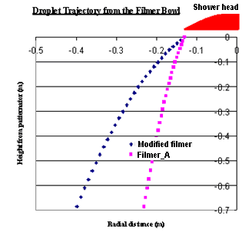
Figure 9: Droplet trajectory

Impact Plate
Hole size
The impact plate hole area is calculated based upon an inner to outer flow split of 45% of the total inlet area. The work has shown that it is desirable that the holes are located as close to the centre line of the shower head as possible. The reason for this is due to the ejection angle of the water from the holes. Even with the holes discharging “full” the ejection angle can be between 10 and 20ْ from the normal, which is enough to put the inner spray beyond a radius of 200 mm. This ejection angle tends to increase if the holes do not discharge “full”.
The hole sizes for the impact plate was calculated from the inner flow area in order to have sufficient number of holes to ensure good circumferential patternation, and for the holes to be contained within a radius of 50 mm to prevent too much over spray (beyond 200 mm radius).
Filmer Gap
The filmer gap clearance between the bowl and the impact plate is critical. If the gap is too large, the outer flow will take more of the inlet water due to having a greater area. If this gap is increased further the bowl will not film and water will just run off the topside of the impact plate. There is also a danger of not achieving a uniform film with a very small gap size, which would result in poor circumferential distribution.

Modified Design Results and Discussion
From carrying out the aforementioned design changes, the modified filmer design produced the patternation results as shown in Fig. 10., with 46.7% of the water being collected within a radius of 200 mm (EU requirement, 50% ±10%). The circumferential water distribution is also within ±30% of the mean total water collected in circuits 1 and 2 for each individual segments within circuits 1 and 2.
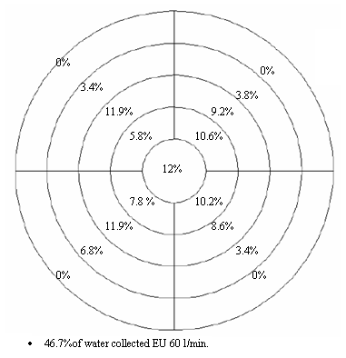
Figure 10: Modified filmer design to conform with EU standards (% water collected).

As shown in Fig. 10 and 11 the radial dsitribution is also greatly improved over the original designs, with the modified design achieving coverage out to a radius of 400 mm. The design therefore meets the proposed EU standard for emergency shower heads.

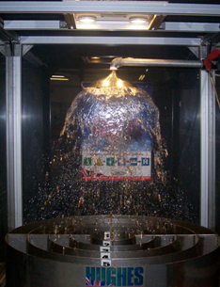
Figure 11: Modified filmer design (60 l/min)..
Conclusions
In this investigation the filming type of shower head has been modified to meet the proposed EU standard for emergency safety showers.
The filming performance, radial and circumferential distribution has been substantially improved due to a number of design changes:

- Reducing the flow area to the filmer plate and impact plate holes. This ensures the holes in the impact plate discharge full and reduces the ejection angle so more water is concentrated within a radius of 200 mm.
- Radial distribution of the filmer water has been increased out to a radius of 400 mm by reducing the exit angle of the filmer bowl.

References

1, Chemical Safety Sheets, Samson Chemical Publishers, 1991.
2, Jane’s Chem-Bio Handbook, Jane’s Information Group, April 2003.
3, Nasr, G.G., Yule, A.J., Burby, M.L, “The Effectiveness of Emergency Safety Showers”, Hughes Safety Showers Ltd, 2005.
4, Draft Content of New EU Standard on Laboratory Showers, Private communications, Mr Tony Hughes (M.D), Hughes Safety Showers Ltd., 2004

